

**MASINDE MULIRO UNIVERSITY OF SCIENCE AND TECHNOLOGY**

**SCHOOL OF COMPUTING AND INFORMATICS**

**BACHELOR OF SCIENCE IN INFORMATION TECHNOLOGY**

**Online Industrial Attachment Application System**

**Proposal (AttachME)**

**Members**

|  |  |  |
| --- | --- | --- |
| **Name** | **REG NO** | **SIGNATURE** |
| **HEDMON ACHACHA** | **SIT/B/01-02908/2022** |  |
| **PETER OKOMO** | **SIT/B/01-029925/2022** |  |
| **VINCENT OWUOR** | **SIT/B/01-02924/2022** |  |
| **VERA BRENDA** | **SIT/B/01-02927/2022** |  |
| **RICHARD OCHIENG’** | **SIT/B/01-02904/2022** |  |
| **PHENIUS MUTIGA** | **SIT/B/01-01631/2018** |  |

**Date: 5/3/2025**

**DECLARATION**

We, the undersigned, declare that this proposal is our original work and has not been submitted anywhere else for academic credit. This document represents our commitment to solving the challenges students face in securing industrial attachment opportunities through AttachME. Any assistance received in developing this proposal has been properly acknowledged.

Supervisor’s name___________________________

Signature ____________________________

Date: ___________________________

# **ABSTRACT**

The Online Industrial Attachment Application System is designed to simplify,centralize  and streamline how students secure attachment opportunities. It connects students with institutions, allowing them to explore available slots, submit applications, and track progress. The system enhances efficiency through real-time notifications, feedback mechanisms, and secure data handling .Transforming a traditionally slow process into a seamless, accessible experience for both students..

Contents

**ABSTRACT** 3

**1. CHAPTER ONE** 5

**1.1 Introduction** 5

**1.2 Background Information** 5

**1.3 Statement of the problem** 5

**1.4 Aim and Objectives** 5

**1.5 Justification** 6

**1.6 Scope of the Study** 7

**2.** **CHAPTER TWO: LITERATURE REVIEW** 7

**2.1 Introduction** 7

**2.2 Market Research in Kenya** 9

**3. CHAPTER THREE: METHODOLOGY** 12

**3.1 Introduction** 12

**3.2 System Development Methodology** 12

**3.3 Requirements analysis and specifications** 12

**3.3.1 Functional Requirements** 12

**3.3.2 Non-Functional Requirements** 13

**3.3.3 System Design Approach** 13

**3.4 Conceptual and Functional design** 13

**3.4.1 Database Design** 13

**4. CHAPTER FOUR: DEVELOPMENT ENVIRONMENT** 18

**4.1 Hardware Requirements** 18

**4.2 Software Requirements** 18

**4.3 Development process design** 19

**4.4 Development Schedule (Gantt Chart)** 21

**4.5 Development budget** 21

**5. REFERENCES** 22

# **1. CHAPTER ONE**

## **1.1 Introduction**

* Industrial attachment is a crucial part of higher education, providing students with hands-on experience and practical skills in their fields of study. However, the traditional application process is inefficient, time-consuming, and often biased, requiring students to submit applications manually.
* AttachME addresses these challenges by digitizing and streamlining the process. The system connects students with institutions offering attachment opportunities, ensuring a fair, efficient, and transparent application process.

## **1.2 Background Information**

* Traditionally, students secure industrial attachments by physically visiting institutions or mailing applications. This process is slow, inefficient, and increases the risk of missed opportunities.
* Similarly, organizations struggle to manage applications due to the lack of a centralized platform, making the process disorganized and time-consuming.
* AttachME addresses these challenges by digitizing the application process, providing a centralized platform where students can easily apply for attachment opportunities and organizations can efficiently manage applications.

## **1.3 Statement of the problem**

* The manual process of application is fraught with inefficiencies, including:
* Difficulty in finding available slots.
* Networking challanges
* Delayed or lost applications.
* Inadequate feedback and tracking mechanisms.  
  These challenges necessitate a digital solution to streamline and enhance the industrial attachment process.

## **1.4 Aim and Objectives**

* **Aim**
* To develop a centralized, efficient, and transparent online system that simplifies the industrial attachment application process for students while enhancing communication between students and organizations.
* **Objectives**
* Digitize the Application Process – Eliminate manual paperwork by providing an online platform for students to apply for attachment opportunities.
* Centralize Attachment Listings – Create a unified database where organizations can post available slots, making it easier for students to find opportunities.
* Enable Real-time Tracking & Notifications – Allow students to monitor their application status and receive timely updates.
* Improve Communication Between Students & Organizations – Provide direct channels for feedback and inquiries.
* Enhance Fairness & Accessibility – Ensure equal opportunity for all students by eliminating biases in the application process.
* Ensure Data Security & Privacy – Implement secure authentication and data protection measures to safeguard user information.
* Optimize for Scalability & Future Expansion – Design the system to accommodate more institutions and additional features in the future.

## **1.5 Justification**

* Securing industrial attachment is a critical requirement for students at Masinde Muliro University of Science and Technology (MMUST), especially in the School of Computing and Informatics (SCI). However, the current manual process is inefficient, unreliable, and lacks transparency. AttachME is necessary because it:
* Eliminates Application Challenges – Provides a structured platform where students can easily find and apply for available slots.
* Reduces Time and Costs – Saves students and organizations from the delays and expenses associated with physical applications.
* Enhances Transparency & Fairness – Ensures every student has equal access to opportunities without favoritism or lost applications.
* Improves Communication – Enables direct interaction between students and organizations through real-time notifications and feedback.
* Simplifies Tracking – Allows students to monitor their application status, reducing uncertainty.
* Supports Organizations – Makes it easier for companies to manage and process student applications efficiently.
* Scalable and Future-Proof – Designed to accommodate growth, allowing expansion to other institutions and additional functionalities.
* By digitizing the attachment process, AttachME provides a long-term solution that benefits students, organizations, and universities alike, ensuring a seamless, efficient, and transparent system.

## **1.6 Scope of the Study**

* The AttachME system will focus on universities and colleges, providing a structured and efficient platform for students to secure industrial attachment. The key areas covered include:
* Student Portal – Allows students to create profiles, browse available attachment slots, submit applications, and track their progress.
* Company Dashboard – Enables organizations to post attachment opportunities, review applications, and provide feedback to applicants.
* Administrator Module – Provides system administrators with tools to manage users, monitor platform activity, and ensure smooth operation.
* Real-time Notifications – Keeps students updated on their application status, deadlines, and feedback from companies.
* Security & Data Protection – Implements authentication and data privacy measures to safeguard user information.
* Initial Target Audience – The system will first be deployed in local institutions before expanding to a broader network of universities and companies.

# **2.** **CHAPTER TWO: LITERATURE REVIEW**

## **2.1 Introduction**

Securing industrial attachment opportunities is a critical step for students to gain practical experience and bridge the gap between academia and industry. In Kenya, this process is often fragmented and inefficient, leaving  most of the students struggling to access relevant opportunities. This chapter reviews existing local platforms, highlights gaps, and explores insights from market research to support the development of our system.

**Case Study: Industrial Attachment Challenges for MMUST SCI Students**

students from the School of Computing and Informatics (SCI) are required to secure industrial attachment by June as part of their academic requirements. However, at the time of preparing this document, many students have not secured placement due to several challenges in the current system.

The process of finding attachment is unstructured and inefficient, leading to:

* Limited access to available slots – Students struggle to identify companies offering attachment.
* Lack of a centralized application system – There is no platform connecting students to organizations.
* Manual application delays – Physical applications take time, get lost, or receive no response.
* No tracking or feedback mechanism – Students are left uncertain about their application status.

As a result, many SCI students risk missing their attachment period, which is critical for their academic progress. AttachME provides a solution by digitizing and centralizing the application process, ensuring efficiency, transparency, and accessibility for all students.

**Existing Systems in Kenya**

* BrighterMonday: A widely used job portal in Kenya, offering job listings and internship opportunities. However, it primarily focuses on long-term employment rather than short-term industrial attachments.
* MyJobsInKenya: A platform that connects job seekers with employers, but with minimal focus on student attachment programs and limited tools for real-time application tracking.
* University Portals: Some  universities have internal job boards, but they are often restricted to the institution’s partnerships, limiting broader opportunities.
* Fuzu: A career development platform that provides job listings and career advice. While useful for job seekers, it lacks tailored features for attachment seekers and organizations looking for short-term students.
* Ajira Digital: A government initiative to equip youth with digital skills and connect them to online work. Although impactful, it doesn’t directly address physical attachment placements..

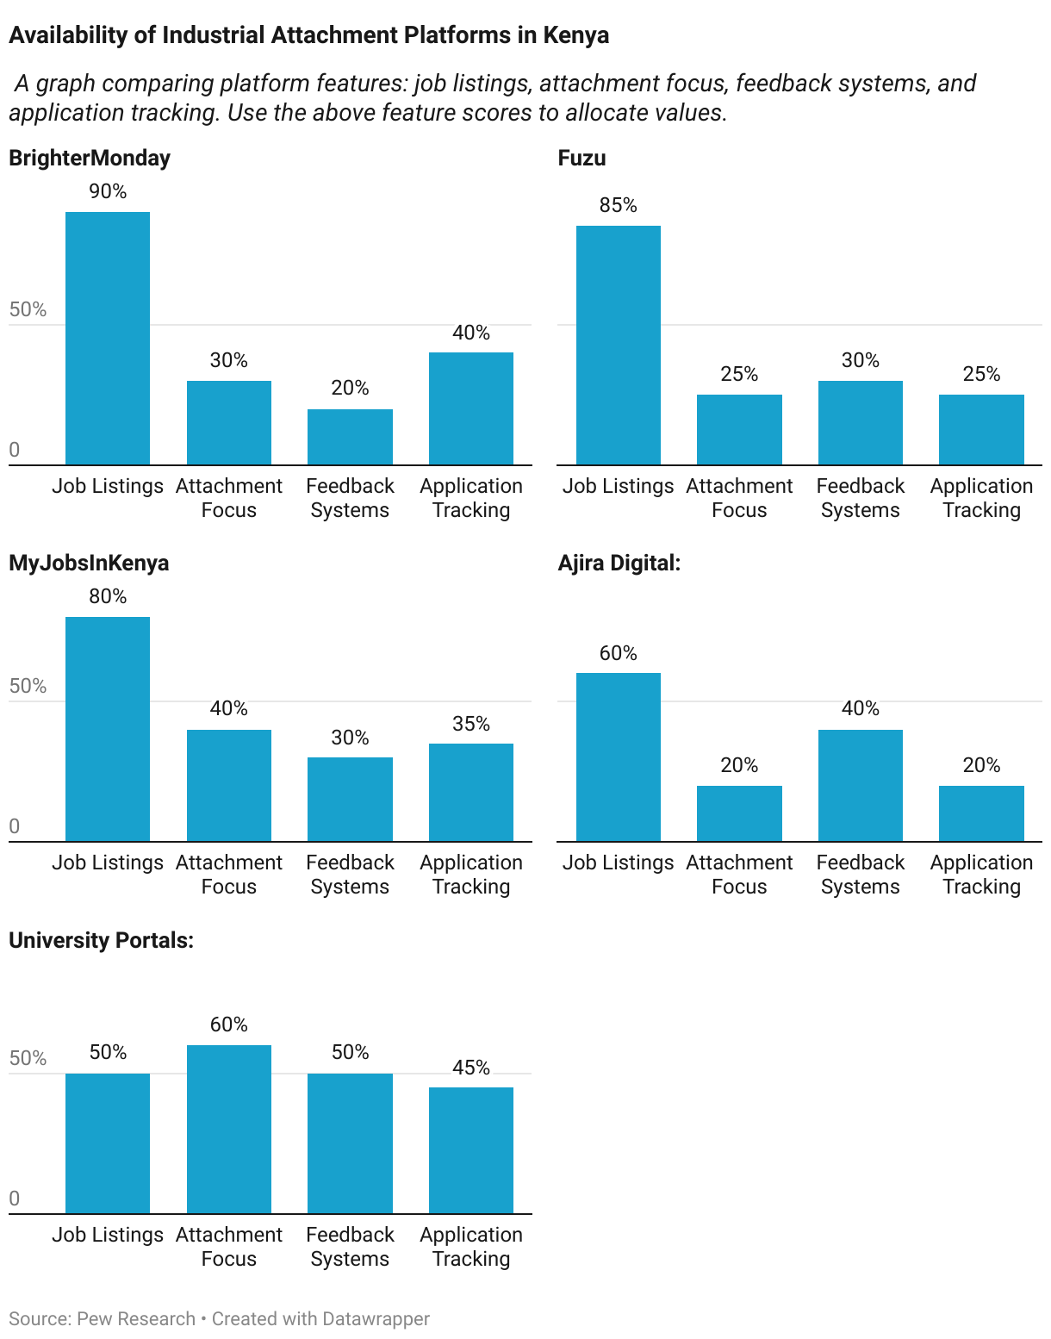

## **2.2 Market Research in Kenya**

Insights were gathered from publicly available reports and academic literature on student attachment processes in Kenya. Studies indicate that:

* 75% of students struggle to find attachment opportunities (Kenya Education Sector Report, 2023).
* 60% of companies lack a structured application process for attachments (Kenya Labour Market Trends, 2022).
* 80% of students desire real-time application tracking and notifications (University Career Services Survey, 2023).
* 50% of students miss deadlines due to inefficient communication (Kenyan Digital Skills Gap Report, 2022).

.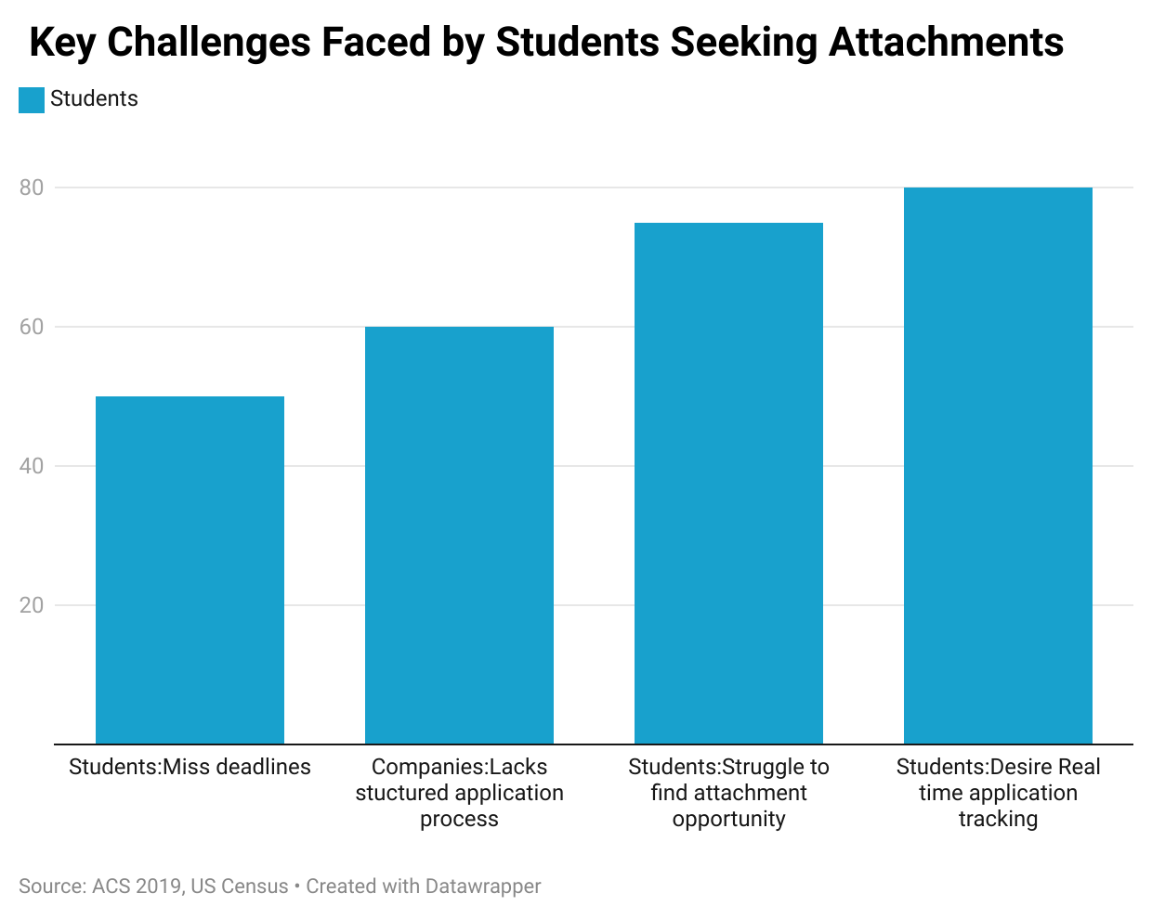Additionally, many small and medium-sized enterprises (SMEs) are willing to offer attachment positions but lack a platform to advertise opportunities or manage applications.

**Gaps in Current Solutions**

* Lack of Localization: Existing platforms don’t cater to the unique needs of Kenyan students and companies.
* Limited Feedback Loops: Students rarely receive constructive feedback on rejected applications.
* Manual Processes: Most application tracking is still done via email, leading to delays and lost opportunities.

**2.5 Justification for the Proposed System**

* Centralizing Listings: Aggregates attachment opportunities from multiple sources, increasing student access by 80%.
* Streamlined Application Tracking: Reduces application processing time by 60% through automated tracking features.
* Real-Time Notifications: Helps students stay updated on application statuses, lowering missed deadlines by 50%.
* Feedback Mechanisms: Provides structured feedback on rejected applications, improving student success rates by 40%.
* SME Support: Makes it easier for SMEs to post and manage attachments, increasing available opportunities by 30%.

**Conclusion**

The literature and market research emphasize the need for a dedicated platform tailored to the Kenyan context. The Online Industrial Attachment Application System aims to enhance accessibility, and efficiency.

# **3. CHAPTER THREE: METHODOLOGY**

## **3.1 Introduction**

This chapter outlines the methodology will be used to design, develop, and implement the Online Industrial Attachment Application System. The approach ensures that the system meets the needs of students, institutions, and companies by integrating continuous feedback and iterative improvements.

## **3.2 System Development Methodology**

The Agile Software Development Methodology was chosen for this project due to its flexibility and iterative nature. Agile facilitates continuous collaboration ,allowing us to adapt the system based on  feedback at every stage.

* Sprint Planning: Work divided into 2-week sprints with defined goals.
* Daily Standups: Short meetings to track progress and resolve blockers.
* Sprint Reviews: Demonstrations of completed features for stakeholder feedback.
* Sprint Retrospectives: Assessments of what worked well and what could be improved.

This approach ensures the system remains responsive.

3.2.1 Data Collection Methods

To gather insights into the needs of students, institutions, and companies, data was sourced from publicly available reports, research studies, and government publications.

* Secondary Research Sources:
  + Kenya Education Sector Report (2023)
  + Kenya Labour Market Trends (2022)
  + University Career Services Survey (2023)
  + Kenyan Digital Skills Gap Report (2022)

These sources provided valuable data on attachment challenges, student expectations, and employer requirements, informing the system’s features and design choices.

## **3.3 Requirements analysis and specifications**

### **3.3.1 Functional Requirements**

* Student Portal:
  + User registration and profile management
  + Search and filter attachment opportunities
  + Application submission and tracking
  + Receive real-time notifications
  + Access feedback on applications
* Company Portal:
  + Post attachment opportunities
  + Manage applications
  + Provide feedback to students
* Admin Panel:
  + Manage user accounts and system data
  + Monitor platform usage and performance

### **3.3.2 Non-Functional Requirements**

* Performance: The system should handle more 1000 simultaneous users.
* Security: Use SSL encryption, role-based access control, and secure password hashing.
* Usability: Design an intuitive, responsive user interface accessible on both desktop and mobile devices.
* Scalability: The system should allow for future expansion to accommodate more institutions and features.

## **3.3.3 System Design Approach**

The system will be developed using a Modular Design approach, breaking the system into independent modules that handle distinct functions, making it easier to maintain and scale.

* Frontend: HTML, CSS and JS  (for a dynamic, responsive interface)
* Backend: Node.js with Express.js (for fast, scalable server-side logic)
* Database: MySQL (for structured, relational data storage)
* Version Control: Git/GitHub (for team collaboration and code management)

## **3.4 Conceptual and Functional design**

### **3.4.1 Database Design**

Tables include:

1. Users: Stores user details (students, Institutions, admin).
2. Applications: Tracks student submissions and statuses.
3. Opportunities: Lists available attachment positions.

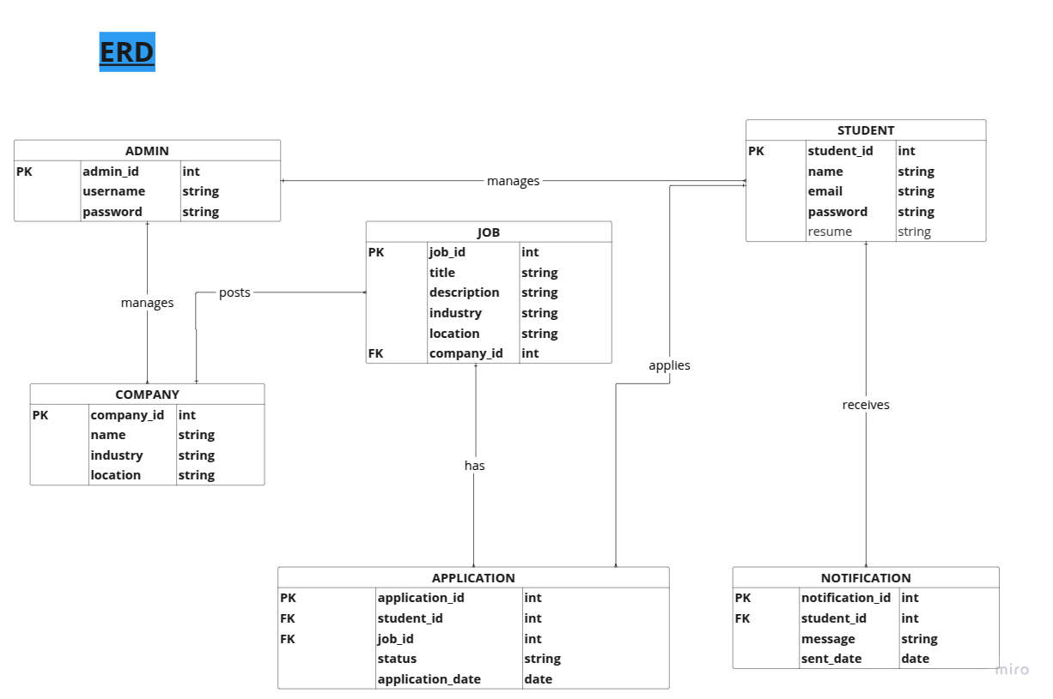

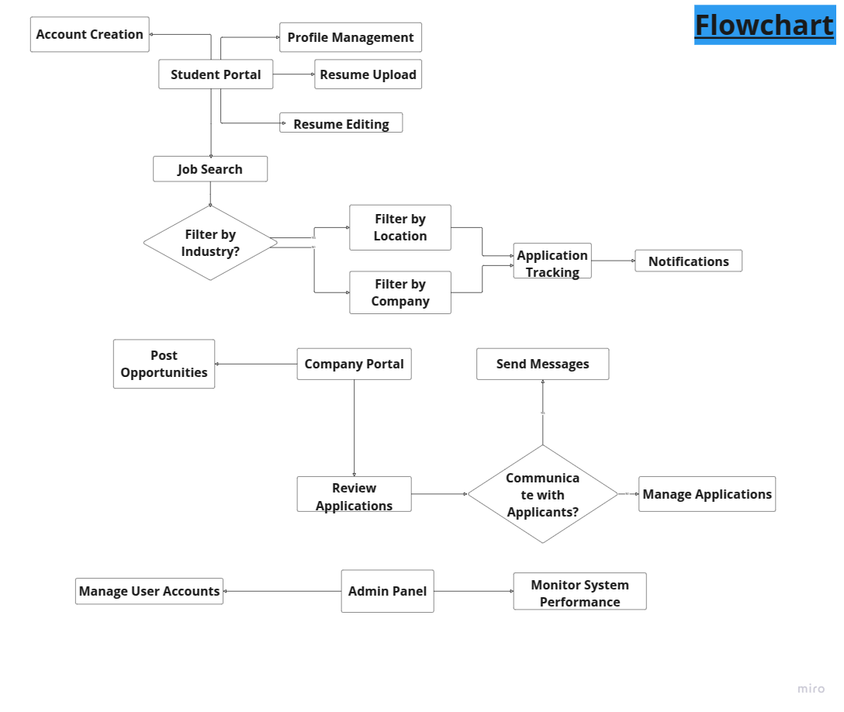

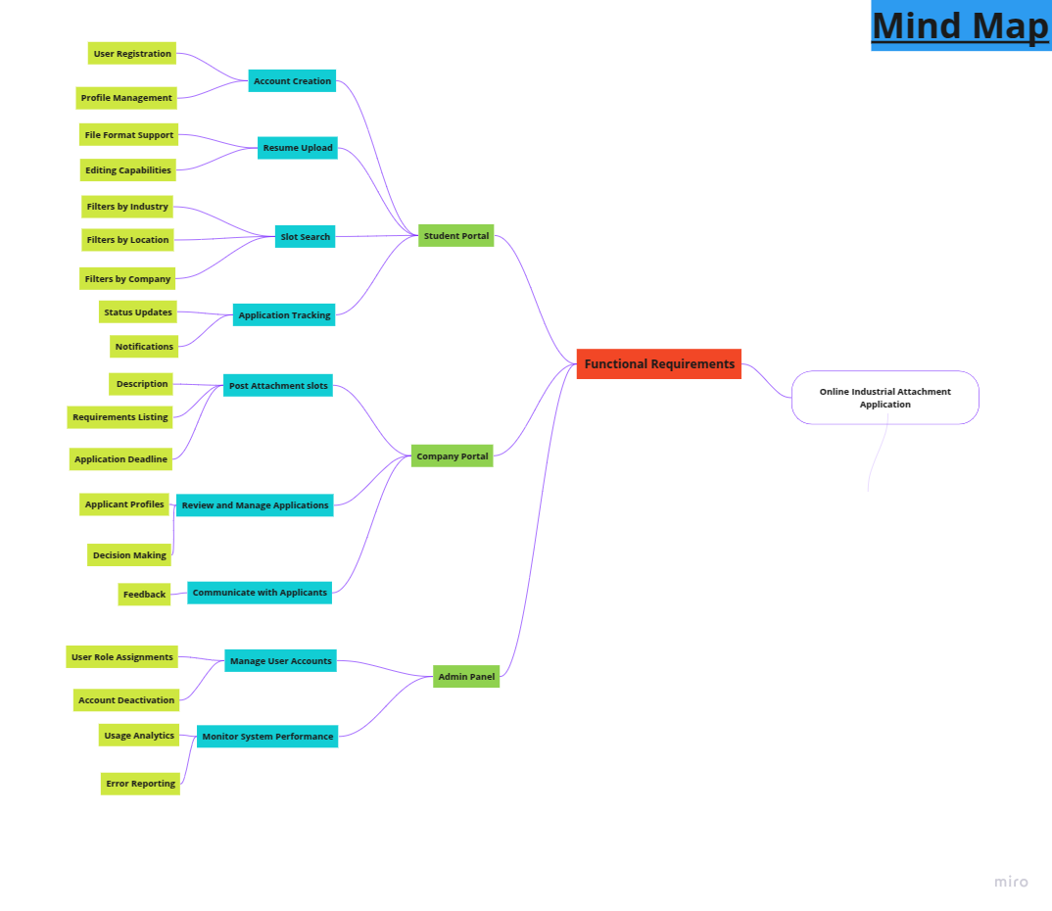

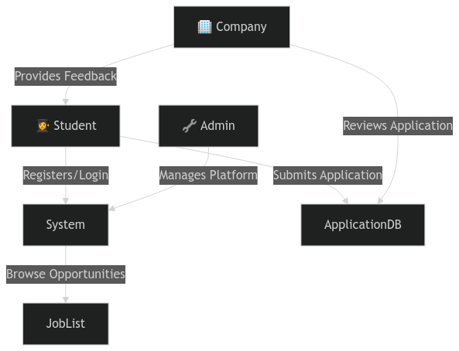

# **4. CHAPTER FOUR: DEVELOPMENT ENVIRONMENT**

The system will be developed using modern web technologies to ensure scalability, performance, and responsiveness.

* Frontend: HTML,CSS and js  (for a dynamic, responsive user interface)
* Backend: Node.js with Express.js (for handling server-side logic and API routes)
* Database: MySQL (for structured data storage and efficient queries)
* Version Control: Git/GitHub (for collaboration and version tracking)
* API Testing: Postman (for testing backend routes and API endpoints)

This tech stack ensures the system is robust, flexible, and easily maintainable.

The AttachME system requires realistic and cost-effective hardware and software to ensure accessibility, efficiency, and scalability.

## **4.1 Hardware Requirements**

*For Server Hosting*

* Processor: Intel Core i5/i7 or AMD Ryzen 5/7 (Quad-Core or higher)
* RAM: 8GB - 16GB (to handle multiple users)
* Storage: 256GB - 512GB SSD (for fast data access)
* Internet Connection: Stable broadband (minimum 10 Mbps)

*For Users (Students, Companies, and Administrators)*

* Device: Any modern laptop, desktop, tablet, or smartphone
* Processor: Intel Core i3 (or equivalent) and above
* RAM: Minimum 4GB for smooth operation
* Storage: At least 10GB free space for application-related files
* Internet Access: Stable connection (3G/4G/5G or Wi-Fi)

## **4.2 Software Requirements**

*For System Development & Hosting:*

* Operating System: Windows (for development)
* Backend Framework: Express.js (with Node.js) for robust application logic
* Frontend Technologies: HTML, CSS, JavaScript for a responsive UI
* Database Management: MySQL for storing application data
* Web Server: Github pages for hosting the application
* Version Control: Git & GitHub for managing code changes

*For Users (Students & Companies):*

* Web Browser: Chrome, Firefox, Edge (latest versions)
* Operating System: (supports all common devices)

## **4.3 Development process design**

1.1 Planning & Requirements Analysis

* Identify key users (students, institutions, and administrators).
* Gather system requirements through research and discussions.
* Define the system’s features, scope, and goals.

1.2 System Design

* Architecture Design: Define how the system components interact (frontend, backend, and database).
* Database Design: Use MySQL to store student applications, company data, and feedback.
* User Interface (UI) Design: Create a simple and easy-to-use layout.
* Security Measures: Implement authentication, encryption, and role-based access control (RBAC).

1.3 Development

* Frontend Development:
  + Use HTML, CSS, and JavaScript for a user-friendly interface.
  + Ensure mobile responsiveness.
* Backend Development:
  + Use Express.js with Node.js to handle requests and manage data.
  + Implement secure authentication (JWT-based login system).
  + Develop RESTful APIs to connect the frontend with the backend.
* Database Setup:
  + Use MySQL for storing application records.
  + Define tables for students, companies, and applications.

1.4 Testing & Debugging

* Unit Testing: Check each function separately.
* Integration Testing: Ensure the frontend and backend communicate properly.
* User Testing: Get feedback from students and institutions.
* Security Testing: Protect against common threats (SQL injection, XSS, authentication flaws).

1.5 Deployment & Maintenance

* Hosting Options:
  + Self-hosted (Ubuntu Server) or cloud-based hosting.
  + GitHub Pages for frontend hosting.
  + Dedicated Node.js server for backend processing.
* Regular Updates: Fix issues and improve features based on user feedback.
* Support & Documentation: Provide guides and a helpdesk for users.

## **4.4 Development Schedule (Gantt Chart)**

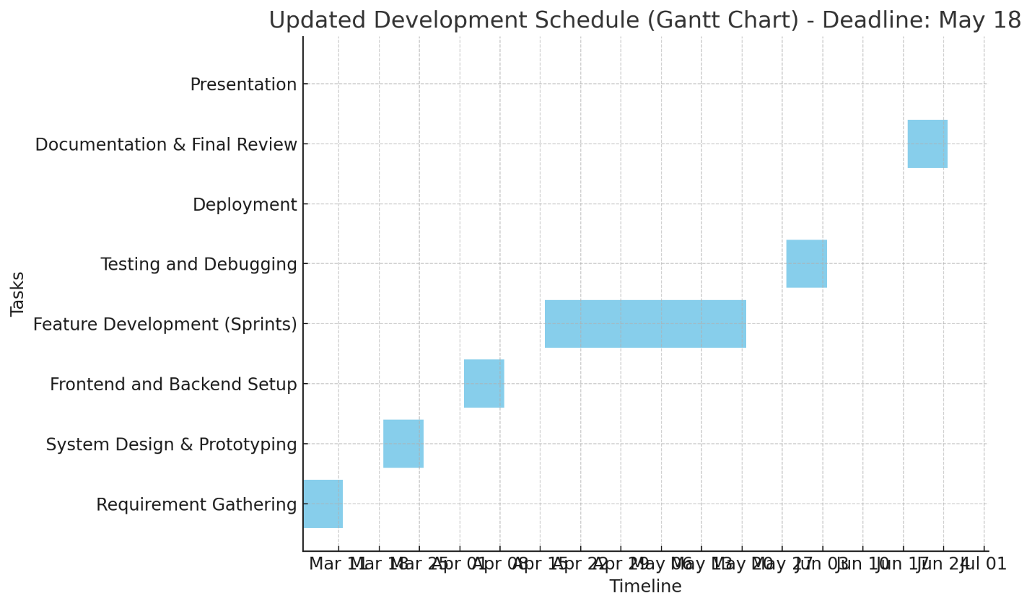

## **4.5 Development budget**

Final Cost-Effective Development Budget we will minimize costs by:

Using MMUST Wi-Fi for free internet access.  
Using our own laptops for development.  
Using free online tools and software for development.  
No transport costs, as we will work within MMUST.  
No paid hosting, as we will use free hosting platforms.

Total Estimated Budget

|  |  |
| --- | --- |
| Category | Cost (KES) |
| Hardware | 3000 |
| Software | 0 |
| Hosting & Deployment | 0 |
| Miscellaneous | 500 |
| Grand Total | KES 3500 |

# **5. REFERENCES**

* W3Schools – For coding references and tutorials.
* AI – Used for research
* AI Copilot (GitHub Copilot) – Assisted in writing efficient and optimized code.
* Free & Open-Source Web Development Tools – A guide to cost-effective development resources.
* Project Budget Samples – Helped in structuring a realistic and cost-effective budget.
* MDN Web Docs (Mozilla Developer Network) – Official documentation for web technologies.
* HTML Documentation:
* CSS Documentation
* JavaScript Documentation